Target Audience / Persona Profile
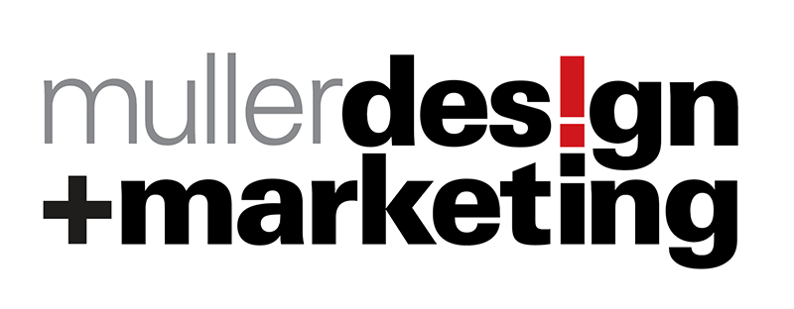

Persona Name:
A persona is a detailed description of your ideal customer, and helps focus your marketing strategy and communications.
(Continued on Next page)
What are their challenges/issues/needs? | Your Solutions/Key messages:
- X  - X  - X  - X  - X  - X  - x | - x  - x  - x  - x  - x  - x  - x
Your Goals and Desired Actions for Persona | Required tactics, content and functionality
- X  - X  - X  - X | (Completed by Muller Design)
How would your persona describe themselves?  Answer Here  What is your persona’s job/role and level of seniority? Answer Here  What does your persona value most? What are they trying to accomplish, achieve, or are working towards?  Answer Here  What is their demographic information? Age range? Income range? Education level? Answer Here  What are common objections to your products or services?  Answer Here  What’s the best way to communicate with this persona? Answer | What experience are they looking for when seeking out your products or services? Answer Here  What does a day in their life look like?  Answer Here  Where do they go for information?  Answer Here  What are some of the keyword phrases they would use in Google to find solutions to their problems? Answer here

Positioning Questions:

Why should a prospect choose you rather than a competitor? (WIIFM)
- X
- X
- x

What’s the biggest issue/problem you help resolve?
Answer Here

